The web should be fast. Executive Summary



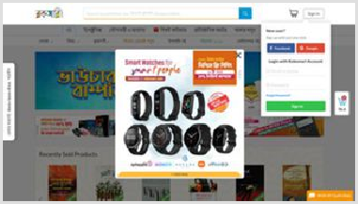Performance Report for:

<http://www.rokomari.com/>

Report generated: Wed, Oct 27, 2021 2:54 AM -0700

Test Server Location:

Using:

Vancouver, Canada

Chrome (Desktop) 90.0.4430.212, Lighthouse 8.3.0

|  |  |  |
| --- | --- | --- |
|  | Performance  30% | Structure  41% |

|  |  |  |
| --- | --- | --- |
| L. Contentful Paint  12.1s | T. Blocking Time  293ms | C. Layout Shift  0.44 |

Top Issues



**IMPACT AUDIT**

|  |  |  |
| --- | --- | --- |
| High | **Avoid enormous network payloads** | Total size was 8.41MB |
| High | **Properly size images** | Potential savings of 4.29MB |
| High | **Efficiently encode images** | Potential savings of 1.66MB |
| Med-High | **Avoid an excessive DOM size** | 3,226 elements |
| Med | **Avoid large layout shifts** | 5 elements found |

Page Details

Total Page Size - 8.41MB

12.1s

## Fully Loaded Time



How does this affect me?

Today's web user expects a fast and seamless website experience. Delivering that fast experience can result in increased visits, conversions and overall happiness.

As if you didn't need more incentive, **Google has announced that they are using page speed in their ranking algorithm.**

About GTmetrix

GTmetrix is developed by the good folks at **Carbon60**, a Canadian hosting company with over 25 years experience in web technology.

<https://carbon60.com/>

IMG 6.18MB

Total Page Requests - 119

IMG 56.3%

|  |  |  |  |
| --- | --- | --- | --- |
| JS 23.5% |  |  |  |

HTML JS

CSS

IMG

Video

Font

Other

History



Page scores

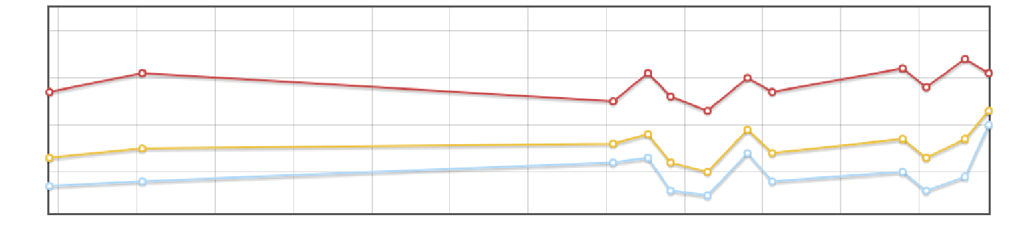

50%

40%

30%

20%

Oct 27 Oct 27 Oct 27 Oct 27 Oct 27 Oct 27 Oct 27 Oct 27 Oct 27 Oct 27 Oct 27 Oct 27 01:55AM 02:00AM 02:05AM 02:10AM 02:15AM 02:20AM 02:25AM 02:30AM 02:35AM 02:40AM 02:45AM 02:50AM

GTmetrix Grade

Performance Score

Structure Score

Page metrics

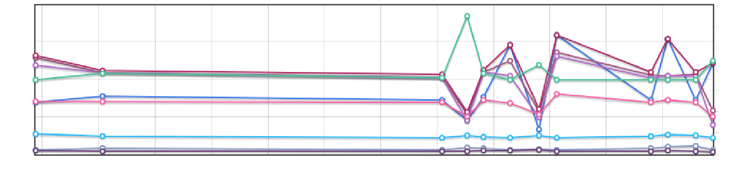

0.7

0.6

15s

0.5

0.4

10s

0.3

5s

0.2

0.1

0s

Oct 27 01:55AM

0.0

Oct 27 02:00AM

Oct 27 02:05AM

Oct 27 02:10AM

Oct 27 02:15AM

Oct 27 02:20AM

Oct 27 02:25AM

Oct 27 02:30AM

Oct 27 02:35AM

Oct 27 02:40AM

Oct 27 02:45AM

Oct 27 02:50AM

Time to First Byte Fully Loaded

First Contentful Paint Total Blocking Time

Largest Contentful Paint Speed Index

Onload Time Cumulative Layout Shift

Time to Interactive

|  |  |
| --- | --- |
| Page sizes and request counts |  |
|  | 150 |
| 9.54MB | 140 |
| 7.15MB | 130 |
|  | 120 |
| 4.77MB | 110 |
| 2.38MB | 100 |

HTML Size

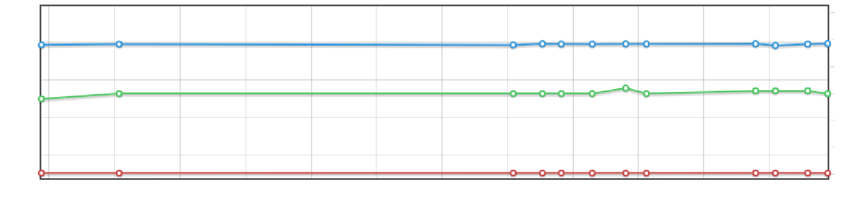

90

Oct 27 Oct 27 Oct 27 Oct 27 Oct 27 Oct 27 Oct 27 Oct 27 Oct 27 Oct 27 Oct 27 Oct 27 01:55AM 02:00AM 02:05AM 02:10AM 02:15AM 02:20AM 02:25AM 02:30AM 02:35AM 02:40AM 02:45AM 02:50AM

Total Page Size

Requests

 Waterfall Chart

The waterfall chart displays the loading behaviour of your site in your selected browser. It can be used to discover simple issues such as 404's or more complex issues such as external resources blocking page rendering.

## Buy Book Online - Best Online Book Shop in Bangladesh | Rokomari.com

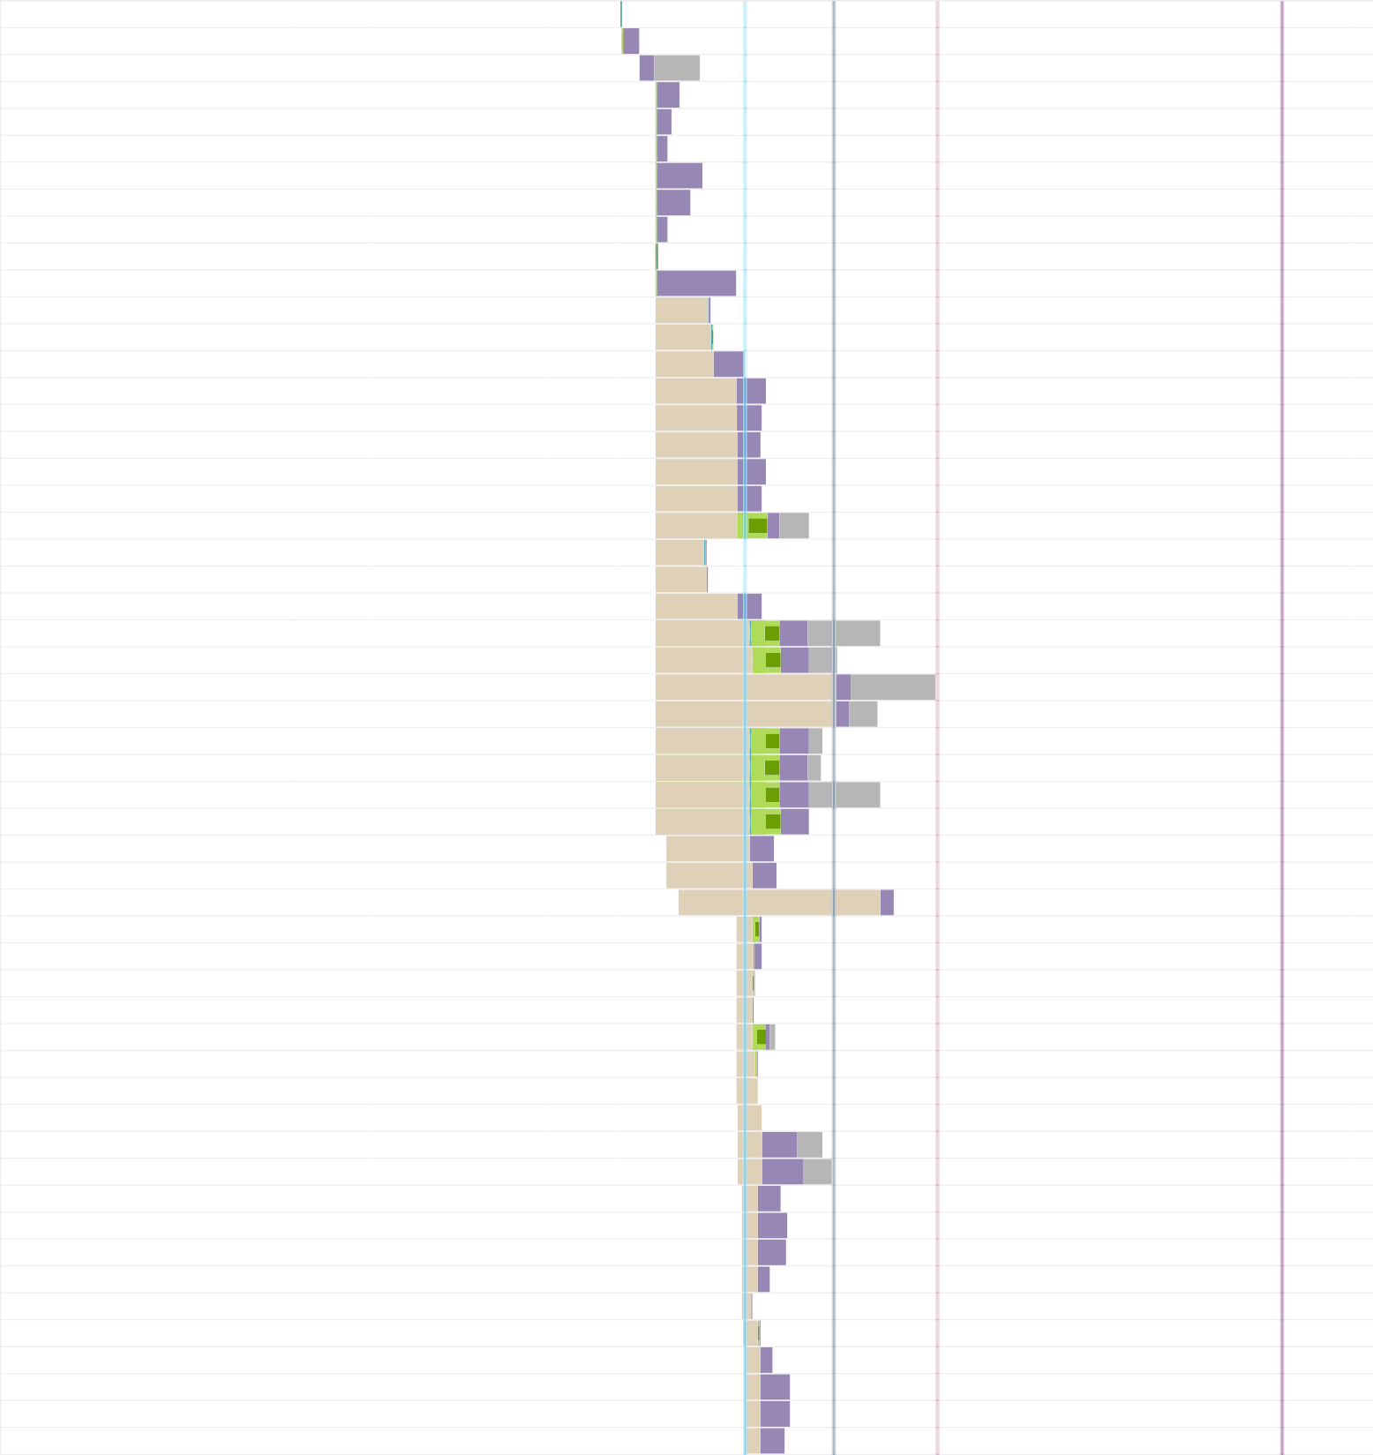**/**

**/ book**

301 rokomari.com 302B

301 rokomari.com 0

200 rokomari.com 1.25MB

34ms

302ms

1.1s

## SiyamRupali.css kalpurush.css fonts.css ionicons.min.css jquery-ui.min.css slick.css

**jquery-ui.min.css bundle6-desktop.css?v=1 js?id=AW-804358854 8875.js**

**rokomari_logo.png icon-fb.png**

**icon-google.png icon-email.png icon-password.png icons8-gift-48.png**

**16f968bafab1_3.png jquery.min.js owl.carousel.min.js floating_button_cart.png**

**261c286c-596e-4b6a-b560-8c9f12444a…**

**cbac5193-df6b-49f4-a7cb-ba028e9df0… 0e16c375-3967-486b-9741-1772b94d1…**

**c0130cc1-a3dc-4ec8-9ca1-30df2aac23… d764b938-420e-4e20-97c0-9a97b251f8…**

**e0056ce5-0c34-477d-ab68-8f59ec90fd… f2c62f48-ba55-4abb-a385-e6d2ca1578… book_av.png**

**custom-category.png user-select-check.png author.png fbevents.js**

**hotjar-452038.js?sv=5 analytics.js gtm.js?id=GTM-TGQ3P6**

200 rokomari.com 233B

200 rokomari.com 192B

200 rokomari.com 588B

200 rokomari.com 7.89KB

200 rokomari.com 7.51KB

200 rokomari.com 604B

200 cdnjs.cloudflare.com 6.58KB

200 rokomari.com 94.8KB

200 googletagmanager.com 38.2KB (canceled) script.crazyegg.com 0

200 rokomari.com 11.9KB

200 rokomari.com 1.08KB

200 rokomari.com 1.38KB

200 rokomari.com 1.22KB

200 rokomari.com 1.28KB

200 rokomari.com 418B

200 s3-ap-southeast-1.am… 195KB

200 ajax.googleapis.com 30.3KB

200 cdnjs.cloudflare.com 9.9KB

200 rokomari.com 1.57KB

200 ds.rokomari.store 1.01MB

200 ds.rokomari.store 105KB

200 ds.rokomari.store 2.41MB

200 ds.rokomari.store 326KB

200 ds.rokomari.store 50.0KB

200 ds.rokomari.store 51.4KB

200 ds.rokomari.store 972KB

200 ds.rokomari.store 28.6KB

200 rokomari.com 23.2KB

200 rokomari.com 1.75KB

200 ds.rokomari.store 6.00KB

200 connect.facebook.net 25.4KB

200 static.hotjar.com 3.30KB

200 google-analytics.com 19.3KB

200 googletagmanager.com 38.0KB

451ms 290ms 229ms

871ms 645ms

231ms 47ms

1.5s

1s 1.1s

1.6s

2s 1.9s

1.9s

2s 2s

935ms 959ms

1.9s

2s 2s

463ms 461ms 328ms 325ms

2.8s

3.3s

3.1s

3s

2.8s

4.1s

4.1s

4.1s

4s

5.1s

## provely-2.0.js

**new-livechat.js?1635328469219 8875.js**

**S6uyw4BMUTPHjx4wXg.woff2 ionicons.ttf?v=2.0.1 SiyamRupali.woff**

200 s3.amazonaws.com 37.4KB

200 static.revechat.com 3.87KB

(canceled) script.crazyegg.com 0

200 rokomari.com 22.8KB

200 rokomari.com 184KB

200 rokomari.com 165KB

697ms 379ms 389ms 448ms

1.5s

1.7s

## call.svg

**cod-small.svg delivery_icon.svg happy-return-big.svg jquery.min.js conversion_async.js ows_logo.svg**

**icon-hotline.png icon-corporate.png icon-mail.png**

200 rokomari.com 1.10KB

200 rokomari.com 1.24KB

200 rokomari.com 0.98KB

200 rokomari.com 1.88KB

200 ajax.googleapis.com 29.0KB

200 googleadservices.com 14.1KB

200 rokomari.com 4.34KB

200 rokomari.com 1.61KB

200 rokomari.com 1.69KB

200 rokomari.com 1.26KB

714ms 831ms 816ms

518ms 188ms

313ms 537ms

841ms 852ms 739ms

## icon_home.png facebook.png twitter.png linkedin.png instagram.png youtube.png icon-rok.png

**icon-app-store.png icon-play-store.png cod.png**

**bkash.png Nagad-Logo.png visa.png**

**master-card.png amex-card.png rocket.png**

**city-bank.png**

200 rokomari.com 1.22KB

200 rokomari.com 1.21KB

200 rokomari.com 1.31KB

200 rokomari.com 1.21KB

200 rokomari.com 2.91KB

200 rokomari.com 42.7KB

200 rokomari.com 3.00KB

200 rokomari.com 321KB

200 rokomari.com 101KB

200 rokomari.com 2.30KB

200 rokomari.com 7.38KB

200 rokomari.com 28.4KB

200 rokomari.com 1.80KB

200 rokomari.com 2.68KB

200 rokomari.com 2.28KB

200 rokomari.com 5.00KB

200 rokomari.com 2.58KB

849ms 773ms 840ms 750ms 841ms

1.4s

536ms

2s

1.4s

841ms 527ms

* 1. s

593ms

851ms 756ms 749ms 851ms

## dmoney.png

**email-decode.min.js pattern_6.png**

200 rokomari.com 179KB

200 rokomari.com 841B

200 rokomari.com 60.8KB

160ms

1.6s

1.1s

## look-inside.png discount-badge-one.png

**discount-badge-three.png discount-badge-two.png serial-badge-2.png back_order.png**

**S6u9w4BMUTPHh6UVSwiPGQ.woff2 kalpurush.ttf**

**jquery-3.3.1.min.js jquery-ui.min.js jquery-ui.min.js popper.min.js bootstrap.min.js**

**bootstrap-datepicker.min.js slick.min.js**

**vendor-desktop.js common-desktop.js**

**client_version_2.html?ver=133899-08… 804358854?random=1635328469659&…**

**modules.bff3b8d60820fc90decc.js 2663779950320576?v=2.9.47&r=stable**

**804358854?random=1635328469659&…**

**804358854?random=1635328469659&…**

**queue-screen-img.png audio-call-avatar.png co-browse.png?9 notify.mp3**

**tr?id=2663779950320576&ev=PageVie… revechat.ttf?1hp4ma tr?id=2663779950320576&ev=Microda…**

200 rokomari.com 4.75KB

200 rokomari.com 2.67KB

200 rokomari.com 2.76KB

200 rokomari.com 2.87KB

200 rokomari.com 1.21KB

200 rokomari.com 2.92KB

200 rokomari.com 22.3KB

200 rokomari.com 307KB

200 rokomari.com 30.6KB

200 rokomari.com 67.8KB

200 rokomari.com 67.7KB

200 rokomari.com 7.28KB

200 rokomari.com 14.1KB

200 rokomari.com 10.4KB

200 rokomari.com 10.7KB

200 rokomari.com 35.4KB

200 rokomari.com 72.9KB

200 static.revechat.com 461KB

200 googleads.g.doublecli… 1.04KB

200 script.hotjar.com 58.5KB

200 connect.facebook.net 87.1KB

200 google.com 42B

200 google.ca 42B

200 static.revechat.com 2.38KB

200 static.revechat.com 4.62KB

200 static.revechat.com 2.28KB

206 static.revechat.com 10.2KB

200 facebook.com 44B

200 static.revechat.com 26.7KB

302 facebook.com 0

630ms 836ms

533ms

863ms 732ms 827ms

323ms

1.6s

907ms 1.2s

* 1. s

843ms 873ms 820ms 875ms

1.1s

1.3s

181ms 55ms 54ms

155ms 55ms 51ms

18ms 14ms 14ms 19ms

36ms

37ms

1.2s

## has_unrated_complete_order dfa6d27be_1861.jpg 4d8e323a85b4_13419.gif 52c4525744e4_4760.gif

**rokimg_20150804_73358.gif 0bc6065a3e54_8412.jpg imgrok_20141110_4900.gif currentTime**

**box-d09a446edefba0dcce5d5143e184… 804358854?random=1635328471284&…**

**?c=13922878235846836142&f=AYx2s… 804358854?random=1635328471284&…**

200 rokomari.com 34B

200 ds.rokomari.store 67.6KB

200 ds.rokomari.store 37.4KB

200 ds.rokomari.store 52.2KB

200 ds.rokomari.store 31.7KB

200 ds.rokomari.store 7.09KB

200 ds.rokomari.store 45.3KB

200 rokomari.com 13B

200 vars.hotjar.com 1.02KB

200 googleads.g.doublecli… 1.07KB

200 cx.atdmt.com 581B

200 google.com 64B

448ms

1.1s

1.1s

1.1s

1.6s

1.4s

1.4s

456ms 48ms

877ms 204ms 40ms

|  |  |  |  |  |  |  |  |  |
| --- | --- | --- | --- | --- | --- | --- | --- | --- |
| **804358854?random=** | **1635328471284&…** 200 google.ca 64B | |  |  | 36ms |  | |  |
| **jquery.min.js** |  | 200 ajax.googleapis.com 29.6KB |  |  | | 19ms | |  |
| **favicon.ico** |  | 200 rokomari.com 6.07KB |  |  | | 18ms | |  |
| **POST campaign** |  | 200 app.provely.io 308B |  |  | |  | 362ms |  |
| **120 Requests** | **9.45MB** | **(13.3MB Uncompressed) Fully Loaded 12.1s (Onload 5.8s)** |  |  | |  |  |  |

# Performance



1.2s 2.4s 3.6s 4.9s 6.1s 7.3s 8.5s 9.7s 10.9s 12.1s

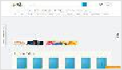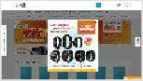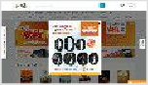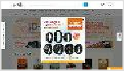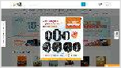

Fully Loaded Time: 12.1s

Largest Contentful Paint: 12.1s

Onload Time: 5.8s

First Contentful Paint: 2.2s

Time to Interactive: 3.9s

|  |
| --- |
|  |
| TTFB: 621ms |
| Redirect: 338ms Connect: 1ms Backend: 282ms |

Performance Metrics

0.44

12.1s

Much more than recommended

Cumulative Layout Shift

How much your page's layout shifts as it loads. A good user experience is a score of 0.1 or less.

Much longer than recommended

Largest Contentful Paint

How long it takes for the largest element of content (e.g. a hero image) to be painted on your page. A good user experience is 1.2s or less.

293ms

5.0s

Longer than recommended

Total Blocking Time

How much time is blocked by scripts during your page loading process. A good user experience is 150ms or less.

Much longer than recommended

Speed Index

How quickly the contents of your page are visibly populated. A good user experience is 1.3s or less.

3.9s

2.2s

Longer than recommended

Time to Interactive

How long it takes for your page to become fully

interactive. A good user experience is 2.5s or less.

Much longer than recommended

First Contentful Paint

How quickly content like text or images are painted onto your page. A good user experience is 0.9s or less.

Browser Timings

|  |  |  |  |  |  |  |  |  |  |
| --- | --- | --- | --- | --- | --- | --- | --- | --- | --- |
|  | | | | | | | | |  |
|  | Redirect | 338ms |  | Connect | 1ms |  | Backend | 282ms |
|  | | | | | | | | | |
|  | TTFB | 621ms |  | First Paint | 2.2s |  | DOM Int. | 3.9s |  |
|  | | | | | | | | | |
|  | DOM Loaded | 3.9s |  | Onload | 5.8s |  | Fully Loaded | 12.1s |  |
|  | | | | | | | | |

Structure Audits



**IMPACT AUDIT**

|  |  |  |
| --- | --- | --- |
| High | **Avoid enormous network payloads** | Total size was 8.41MB |
| High | **Properly size images** | Potential savings of 4.29MB |
| High | **Efficiently encode images** | Potential savings of 1.66MB |
| Med-High | **Avoid an excessive DOM size** | 3,226 elements |
| Med | **Avoid large layout shifts** | 5 elements found |
| Med | **Serve static assets with an efficient cache policy** | Potential savings of 1.41MB |
| Med-Low | **Use HTTP/2 for all resources** | Potential savings of 3.5s |
| Med-Low | **Avoid document.write()** | 1 instance found |
| Med-Low | **Avoid chaining critical requests** | 22 chains found |
| Med-Low | **Use a Content Delivery Network (CDN)** | 17 resources found |
| Med-Low | **Defer offscreen images** | Potential savings of 708KB |
| Low | **Avoid multiple page redirects** | Potential savings of 337ms |
| Low | **Avoid long main-thread tasks** | 7 long tasks found |
| Low | **Ensure text remains visible during webfont load** | 5 fonts found |
| Low | **Serve images in next-gen formats** | Potential savings of 4.86MB |
| Low | **Use passive listeners to improve scrolling performance** | 1 event listener not passive |
| Low | **Reduce unused JavaScript** | Potential savings of 375KB |
| Low | **Eliminate render-blocking resources** | Potential savings of 77ms |
| Low | **Enable text compression** | Potential savings of 28.0KB |
| Low | **Preconnect to required origins** | Potential savings of 152ms |
| Low | **Reduce unused CSS** | Potential savings of 111KB |
| Low | **Reduce JavaScript execution time** | 514ms spent executing JavaScript |
| Low | **Minify CSS** | Potential savings of 21.4KB |

|  |  |  |
| --- | --- | --- |
| Low | **Reduce initial server response time** | Root document took 282ms |
| Low | **Avoid serving legacy JavaScript to modern browsers** | Potential savings of 28.3KB |
| Low | **Avoid non-composited animations** | 65 animated elements found |
| Low | **Minify JavaScript** | Potential savings of 13.2KB |
| N/A | **Largest Contentful Paint element** | 1 element found |
| N/A | **Minimize main-thread work** | Main-thread busy for 2.8s |
| N/A | **Reduce the impact of third-party code** | Total size was 632KB |
| N/A | **User Timing marks and measures** | |